Adrian Turion |  | Avenue de Sainte-Clotilde 9  1205 Geneva, Switzerland | 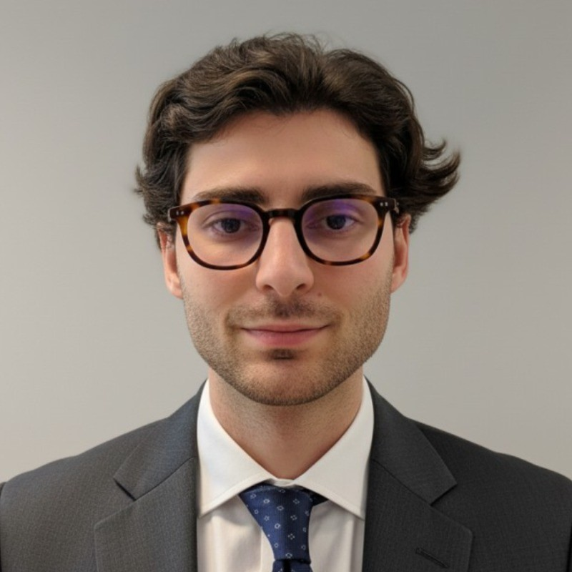
turionadrian@gmail.com | Swiss national | 10.11.2000 |  | +41 77 262 37 96
INTRODUCTION
M&A analyst based in Geneva with 1–2 years of small & mid-cap cross-border deal experience in Switzerland and Europe, strong financial modelling and valuation skills, and prior M&A and FP&A internships. Now keen to contribute to Deutsche Bank’s Swiss Corporate Finance Team in Zurich and work on larger, complex M&A and capital markets transactions.
WORK EXPERIENCE
Auraïa Capital Advisory – Small & Mid Cap Cross-border M&A Boutique  Mergers & Acquisitions Analyst (Converted internship into full-time position) |  | Geneva, Switzerland  Aug 2024 – Current
- Execute small & mid-cap M&A and capital raising mandates in Switzerland and Europe (sell-side, buy-side, fundraising) across healthcare, tech & software, services and industrials, taking an active role on live transactions in lean deal teams.
- Build and maintain detailed financial models (DCF, LBO, trading & transaction comparables, scenarios and sensitivities), prepare valuation materials and support the drafting of client presentations, teasers and information memoranda.
- Coordinate due diligence processes and communication with legal, tax and other advisers, while using data- and AI-driven tools to screen targets and buyers and to structure deal pipelines.

RC Group – Currently under LBO with Crédit Mutuel Equity  Mergers & Acquisitions Intern |  | Paris, France  Feb 2024 – Aug 2024
- Supported the CEO of the Healthcare & Retail division on a cross-border buy-and-build strategy, leading target screening and management discussions for 180+ companies and contributing to financial analyses and investment memos that underpinned advanced negotiations with shortlisted acquisitions

Europ Assistance – Subsidiary of Generali Insurance  Financial Analyst Intern |  | Geneva, Switzerland  Apr 2023 – Aug 2023
- Built P&L models and three-year forecasts across 27 B2B contracts (~CHF 20m revenues), supporting the CFO on budgeting, scenario analysis and strategic initiatives, and preparing concise materials for management committees

LEADERSHIP
- Finalist – Keyrock x McKinsey 2024: co-developed a quantitative model using order book and market data to forecast disruption scenarios and presented strategic recommendations under time pressure to Keyrock leadership and McKinsey partners
- Associate – AIESEC: relaunched post-COVID business development by sourcing corporate leads, producing tailored pitchbooks and negotiating three partnerships (~CHF 60k), significantly increasing volunteer placements
EDUCATION
HEC Lausanne  Master of Science in Finance |  | Lausanne, Switzerland  2021 – 2024
- Cumulative GPA: 5.2/6.0 (Top 15% of the class cohort)
- Exchange programs at Waseda University (Tokyo, Japan) and Maastricht University (Maastricht, Netherlands)
- Relevant Coursework: Corporate Finance, Valuation, M&A, Private Equity, Venture Capital
- Thesis Topic: Synergies Analysis of the Merger between American Airlines & US Airways

Bachelor of Science in Management |  | 2018 – 2021
- Cumulative GPA: 4.7/6.0

Scientific Baccalaureate (French National Baccalauréat) - Highest Honors (16.6/20) |  | Aix-en-Provence, France
ADDITIONAL INFORMATION
Languages:  Computer:  Interests:  References: | French (Native, C2), Spanish (Native, C2), English (Fluent, C1)  German (business proficient – currently strengthening ahead of relocation to Zurich in 2026)  Excel, PowerPoint, Macabacus, FactSet, Capital IQ, Bloomberg, VBA, AI workflows & automations  Geopolitics, Badminton (Provence regional finalist), Gym, Real use cases of Artificial Intelligence  Guillaume Arnaldez – Ex-Director at Auraïa Capital Advisory, guillaume.arnaldez@auraia.ch

